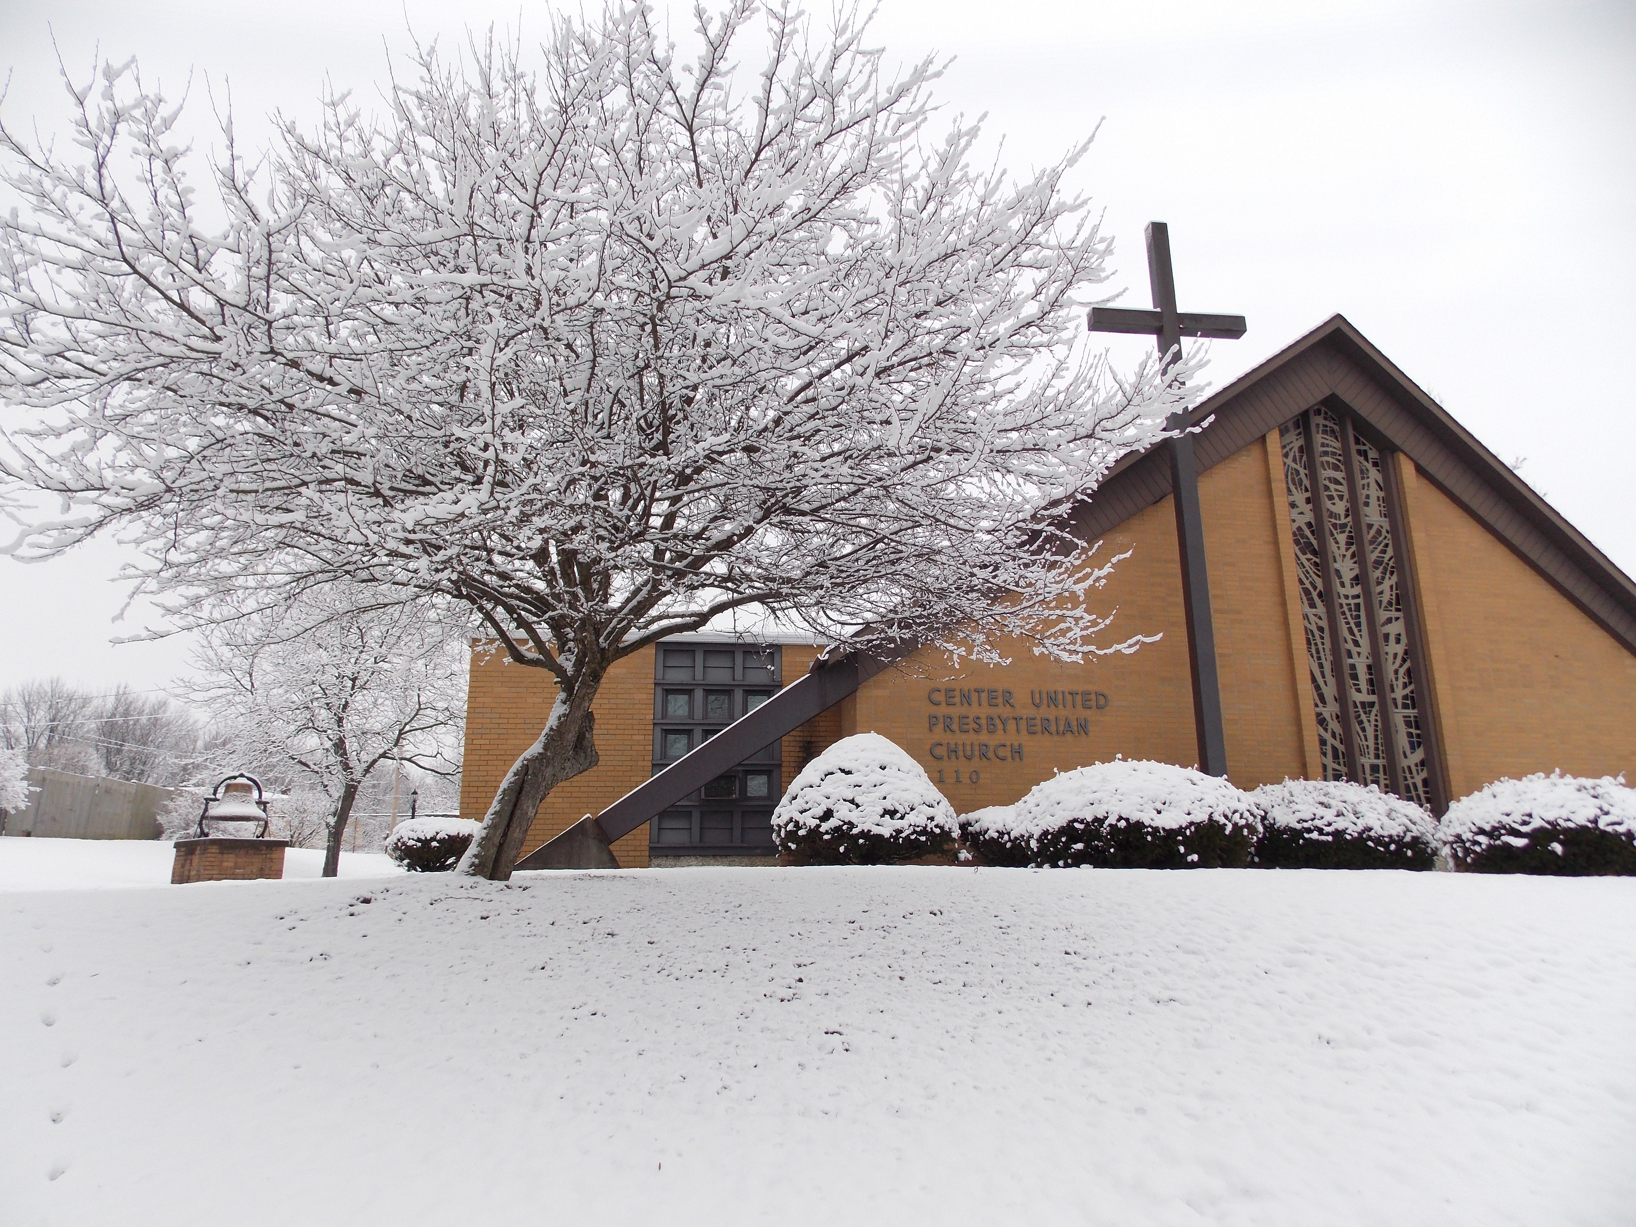
Center U.P. Church Newsletter – November/December 2018
Office Hours ~ Mon: 9am-noon; Tue: 9am-noon; Thur: 9am-noon Phone: 724-796-3351 email: centermidway@rocketmail.com Mobile Phone: 724-678-6976 website: www.centermidway.com
Salutations from the Pastor

One of my favorite bands growing up was Caedmon’s Call. Perhaps their most unique album is Share the Well, which was written in India. There are some very interesting songs, interweaving the culture and struggles and faith that they discovered there. One of the songs is called “Two Weeks” and is about a young woman who gets on a plane for two weeks in Africa, the people she meets, the children she is blessed by, and the love and wonder that she takes back with her, and cherishes, until the day many years later when she returns to that place and those people that changed her life forever.
Part of the purpose of the song is to create a greater awareness of the needs in the world; part is to celebrate the wonder of new places and experiences; but more than anything – to express beautifully the gift of God – to show what happens when we respond to Christ’s call to “Go!” It’s not about having a once-in-a-lifetime experience (though that’s certainly true). It’s not about going in and being a hero and making an impact (though by God’s grace, He does work through us to bless others). It’s about obedience to the call. It’s about being available for what the Lord wants to do with you. It’s about trusting in His ever-faithful, loving, sovereign care over you with each step and every breath.
Our church Session recently had a visit from Rusty Salminen – our liaison with our partners in Ethiopia – as well as Qes Endrias Essay – the President of the Southwest Bethel Synod there. Endrias made the special visit to our Presbytery to help spur us on to evangelism, because his prayer is that we would have greater growth of disciples of Jesus, as they have experienced in his country. We have the opportunity to strengthen this bond between our brothers and sisters on the other side of the world. This relationship is worth our investment and commitment. There are lots of ways to do this – including supporting the Charles Haspels Bible School for training pastors! How are you able to offer your time, talents, treasures, and influence in a way that ushers in Christ’s kingdom? How can you be a conduit of his grace, his healing, his redeeming work?
None of us may personally know the people of our partner church Gazika Bethel, or the churches in SWBS, but there is no reason for that to keep us from praying on their behalf. Gazika has specifically asked prayer for their new land and development of a new church building (as they have outgrown the old one), another “evangelist” (preacher and worship leader) and a fully trained pastor. Will you pray for their churches, their ministries, their communities? Will you pray that those around them will come to know and follow our wonderful Savior, that we would learn new things about sharing the good news of Christ, and that He will make us all one? Go in the love and power of Christ … wherever He may send you! ~ Pastor Brian

Events
November 11th – Harvest Home Sunday Please bring an item for the Food Bank (Nov. 4 or before worship on the 11th) and join us in giving thanks to God for his goodness!
Wed. Nov. 14th - Joint Thanksgiving Service Join us at Center U.P. Church at 7:00 PM as our brothers and sisters from Midway United Methodist join us for worship and fellowship afterwards.
Sat. December 1st – Greening of the Church Join the Mariners as we green the church and decorate our facilities for the season – 4:00 PM with a meal to follow.
December 2nd - Advent Communion Please prepare your hearts for the Sacrament and for of journey of Advent together.
Sat. December 8th - Breakfast with Santa (9:00-11:00 AM) in Fellowship Hall.
December 24th - Christmas Eve Candlelight Service (7:00 PM) – please join us for this special and holy night.

Birthdays

11/04 Becky Michalka 12/02 John Stone
11/07 Doug Baird 12/03 Jess Geisler
11/07 Dale Baird 12/06 Hayden Fillhart
11/10 Rose Tournay 12/07 Joe Phillis
11/24 Jean Baird 12/08 Betty Lamb
11/26 Karen Brockman 12/09 Tylor Fodse
11/30 Judi Bayer 12/11 Jean Hannan
12/17 Brian Kilbert
12/20 Lauren Gallucci

“Best Noel” Christmas Play

Unfortunately, the play has been cancelled due to lack of participation, but revisions are being made, so maybe next year! Please spread the word to those who may want to know.

Choir

Wonderful News! The choir has started, and it looks like an exciting fall/winter season is upon us. We have nine members so far with a few others we hope will join soon. We welcome anyone who would like to come and sing along with us. Choir practice is a time of fellowship, prayers, and joy - we look forward to more members. At this time I would like to thank Pastor Brian for all his support, along with the members of the choir, who are all offering a wonderful music ministry for the church services. At the present time, our practices are on Thursday evenings at 7:30 PM, and last about an hour. We are working on Sunday anthems for church, Thanksgiving hymns for November, and are beginning to find songs for Advent and Christmas. We hope you all will enjoy the worship through the music and words of the songs that we sing. God Bless!
- Margie Boggs, Organist / Choir Director

Deacons & Fellowship Committee

Fort Cherry Helping Hands: We continue to support the Fort Cherry Helping Hands ministry by asking for specific items to be donated to this ministry. For all of November we are collecting non-perishable canned fruit & veggies.

Breakfast with Santa: Join us for pancakes, sausage and SANTA! Tickets are $7.00 – kids under 12 eat free with the purchase of an adult ticket. Proceeds benefit the Fort Cherry Angel Tree. All parents should bring their own camera to take their own pictures. We plan to have crafts & face painting as well. Spread the word!

Fellowship of the Skein

We continue to meet once a month for a great time of fellowship and crafting. This group is open to anyone in the community at any yarn craft level. We meet from 8:30 to 10:30 AM in the fellowship hall unless otherwise notified due to schedule conflicts. We normally meet the third Saturday – unless rescheduled. Join us!

Mariners

On Oct. 13th (6:00 PM) we had a wonderful covered dish meal with beautiful desserts – a great start to an interesting evening shared with the Midway Fire Dept. Doug and Dale Baird helped us understand the concerns of being a volunteer and all the business that Company #13 has on a year-to-year need. On Nov. 10th (6:00 PM) we will meet again in the Fellowship Hall (we’re “just around the corner”). Hosts are the Whoolerys, Linda Nickelson and the Bish’s. Decorations are ready, the menu in place, so if you have an urge to eat out, please come along; everyone is always welcome – the highlight will be a “Brown Bag Auction” – please include an item worth at least $5 in your bag – as a starting place – proceeds will go to the mission concerns of the Mariners. Also remember, that the Greening of the Church will be on Saturday December 1st (beginning at 4:00 PM and ending with a pizza party). The men start and get the tree ready on Friday morning (Nov. 30th) at 10:00 AM. Then the Mariners and others come along the next day (Sat.). Please mark your calendars and come share the Spirit as we look forward to Christmas and all the Lord & Savior has planned for 2019. Any questions, call Roger Romestan or Dan Hillberry (724-796-0505). Happy Advent and blessed holidays!

Session

The November Session meeting will be the 2nd Monday – November 12th – at 7:00 PM. The Trustees are invited to meet at that time as well if possible. Please NOTE the change from normal schedule.

Sunday School

Please join one of our classes as an important part of our discipleship and spiritual growth as individuals and a church (9:45 AM - Sundays).
Swiss Steak Dinner
Once more, we extend a hearty “Thank you” to all those who supported our steak dinner! We had so many great helpers! Thank you to the volunteers, the patrons and everyone who donated items. It was a success and we raised $1,961.74.

Treasurer’s Report (September)
Beginning Checking Acct. $6,404.00 Envelopes $8,070.00 *Other Receipts (yard sale, etc.) $ 894.65 Expenses - $10,096.12 Ending Balance in Acct. $5,272.53
We’d like to remind and encourage all members to please pay their Per Capita to support the mission of our broader Presbytery. For 2019, the Per Capita will be $36.05 for each member in your household – this is the portion for Presbytery & Synod – we continue to withhold from General Assembly, but you may pay that additional portion ($8.95) to Betty Lamb if you choose. Thank you.
Trustees
The Trustees are happy to report that at long last the church will be undertaking a project to replace the windows in the sanctuary. We have contracted with Pittsburgh Stained Glass Company and, along with a local company here in Midway, they will rebuild and replace the windows while keeping the current beautiful stained glass.


As many of you are aware, some of the windows will not close, some of the cranks are not operational, and the sashes have deteriorated with age. We are excited that the renovation project will include removing the old window sashes and replacing these with new sashes, new jams, and thermo-pane windows. In addition, we will be able to save the stained glass that has been a feature of our sanctuary and restore it in the new window structure. The new windows will also be treated with a UV resistant coverage which should assist in preserving the pew cushions. Of course, this will not be an inexpensive project. The project cost is estimated at $59,100. The Session and Trustees are asking for your help in funding the repairs.
If you or your family would like to donate a window in memory or honor of a loved one, the cost will be $2,000 per window. All windows purchased in honor or memory of someone will be announced at the dedication and maintained in the church Memory Book. Contributions of any amount to the window fund will be greatly appreciated should you not wish to purchase a full window. Donations to the window fund should be made payable to the church with a memo indicating that the funds are for deposit to the building fund to assist with the “window replacement project.”

Should you have questions, please contact Betty Lou Lamb or any member of the Trustees. We thank you in advance for your kindness and generous support of this much needed project.

Youth Group
The Youth Group had a GREAT time at Fun Fore All in Cranberry on Oct. 21st – the cold didn’t stop us. We carved pumpkins with other families from the community on Oct. 28th. And we have more planned for the Fall & Winter (including caroling on Dec. 16th). We normally meet Sunday evenings (6:00 to 7:45 PM) – ages 11 to 18 invited – and bring friends! Check with Pastor Brian for special events/outings. Thanks to Dave and Jill Sims for joining the roster of volunteers for 2019!


A Devotional for you ~ “Sound doctrine [is] in accordance with the gospel of the glory of the blessed [that is, happy] God.” (1 Timothy 1:10–11)
Listen to what John Piper says about this verse: “This is the gospel – ‘the gospel of the glory of the happy God.’ That’s a quote from the Bible! It is good news that God is gloriously happy. No one would want to spend eternity with an unhappy God. If God is unhappy, then the goal of the gospel is not a happy goal, and that means it would be no gospel at all.”
A great part of God’s glory is his happiness. Have you ever thought about it that way? It was inconceivable to the apostle Paul that God could be denied infinite joy and still be all-glorious. To be infinitely glorious was to be infinitely happy. He used the phrase, “the glory of the happy God,” because it is a glorious thing for God to be as happy as he is — infinitely happy. God’s glory consists much in the fact that he is happy beyond our wildest imagination. This infinite, divine happiness is the fountain from which the Christian drinks and longs to drink more deeply. Can you imagine what it would be like if the God who ruled the world were not happy? What if God were given to grumbling and pouting and depression, like some Jack-and-the-beanstalk giant in the sky? What if God were frustrated and despondent and gloomy and dismal and discontented and dejected? Could we join David and say, “O God, you are my God; earnestly I seek you; my soul thirsts for you; my flesh faints for you, as in a dry and weary land where there is no water” (Psalm 63:1)? I don’t think so. We would all relate to God like little children who have a frustrated, gloomy, dismal, discontented father. They can’t enjoy him. They can only try not to bother him, or maybe try to work for him to earn some little favor. But that is not the way God is. Psalm 147:11 says, he “takes pleasure . . . in those who hope in his steadfast love.” So the aim of the “Christian hedonist” (a John Piper phrase I like) is not to avoid this God, not to run from him, or tiptoe through the living room lest his gloominess become anger. No, our aim is to hope in his steadfast love. To run to him. To be happy in God, to delight in God, to cherish and enjoy his fellowship and favor.
Jesus invites us to spend eternity with a happy God when he says, “Enter into the joy of your master” (Matthew 25:23). Jesus lived and died that his joy — God’s joy — might be in us and our joy might be full (John 15:11; 17:13). Therefore, the gospel is “the gospel of the glory of the happy God.” The happiness of God is first and foremost a happiness in his Son. Thus when we share in the happiness of God, we share in the very pleasure that the Father has in the Son. This is why Jesus made the Father known to us. At the end of his great prayer in John 17, he said to his Father, “I made known to them your name, and I will continue to make it known, that the love with which you have loved me may be in them, and I in them” (John 17:26). He made God known so that God’s pleasure in his Son might be in us and become our pleasure in him. Let’s start acting like the good news is as good as it actually is! Amen.

